**LAB 3**

**Q1. Count how many vowels are there in a string. Accept the string from the user.**

print("Name: KanavShahPatel")

print("Roll Number: 24BEE107")

a = input("Enter a string")

a.lower()

b=len(a)

c=0

fori in range (b):

if(a[i]=='a' or a[i]=='e' or a[i]=='o' or a[i]=='u' or a[i]=='i' ):

c+=1

print(f"The number of vowels are : {c}")

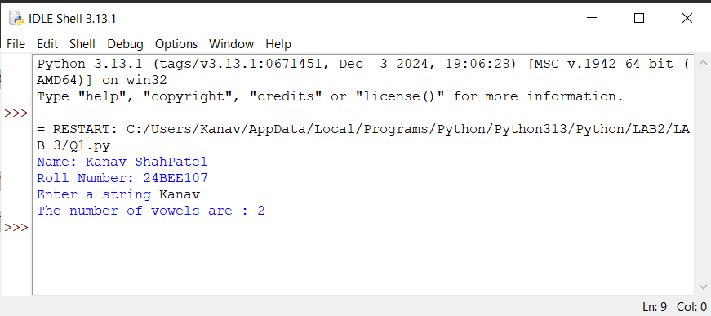

**Q2. Write your own functions (without using built-in functions) to convert all characters of a string into lower case/upper case/toggle case**.

print("Name: KanavShahPatel")

print("Roll Number: 24BEE107")

a = input("Enter a string")

def lower(b):

result = ""

fori in b:

if('A'<=i<='Z'):

result+= chr(ord(i)+32)

else:

result+=i

print(f"Lowercase ={result}")

lower(a)

def upper(b):

result = ""

fori in b:

if('a'<=i<='z'):

result+= chr(ord(i)-32)

else:

result+=i

print(f"Uppercase ={result}")

upper(a)

def toggle(b):

result = ""

fori in b:

if('a'<=i<='z'):

result+= chr(ord(i)-32)

elif('A'<=i<='Z'):

result+=chr(ord(i)+32)

else:

result+=i

print(f"Toggle case ={result}")

toggle(a)

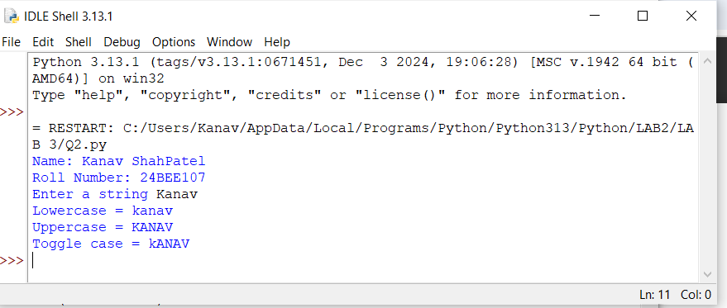

**Q3. Accept two strings. Check whether one string is there in another string.**

print("Name: KanavShahPatel")

print("Roll Number: 24BEE107")

a = input("Enter the first string")

b= input("Enter the second string")

isthere= False

fori in a:

ifi in b :

isthere=True

ifisthere:

print("The string is present in other")

else:

print("The string is not present in another")

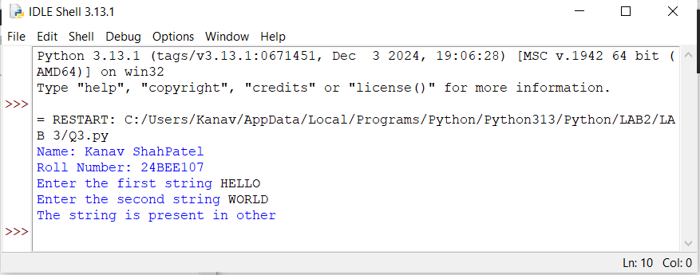

**Q4. Write a function that removes one string from another string, if present. E.g. Onestring = “abcdef”, removestring = “cd”. The finalstring should contain “abef”.**

print("Name:Kanav ShahPatel")

print("Rollno :24BEE107")

def remove_substring(onestring, removestring):

Removes the first occurrence of 'removestring' from 'onestring'.

If 'removestring' is not found, returns the original 'onestring'.

return onestring.replace(removestring, "", 1)

onestring = "abcdef"

removestring = "cd"

finalstring = remove_substring(onestring, removestring)

print("Final string:", finalstring)

